ABAP/4
ABAP Part III LAB BOOK

Table of Contents
Table of Contents 2
Getting Started 3
Lab 1-1 BDC and LSMW 4
Lab 2-1 Enhancements and Modifications 10
Lab 3-1 Smartforms 18
Lab 4-1 Adobe Forms 22
Lab 5-1 ALE and IDOCS 24
Lab 6-1 Transports 28

Getting Started

Overview
This lab book is a guided tour for learning SAP ABAP. It comprises of assignments to be done. Refer the demos and work out the assignments given by referring the case studies which will expose you to work with Java applications.

Setup Checklist for SAP ABAP
Here is what is expected on your machine in order to work with lab assignment.
Minimum System Requirements
- Intel Pentium 90 or higher (P166 recommended)
- Microsoft Windows 2010 or higher.
- Memory: (8GB or more recommended)

Please ensure that the following is done:
- SAP GUI is installed
- Connection to the SAP Server is present

Lab 1-1 BDC and LSMW
Goals | - To know the data migration techniques and how to upload the data through the BDC Session method and Call Transaction Techniques.  - Data upload through the LSMW tool
Time | 4 Hours
Lab Setup | Connectivity to SAP server  Login details for connecting SAP server

- Perform the BDC Recording for Customer Master data and create a program for the same.

Step # 1. Go to SHDB T-code and start the recording for the customer master info using the transaction code XD01 as shown in the below screen.

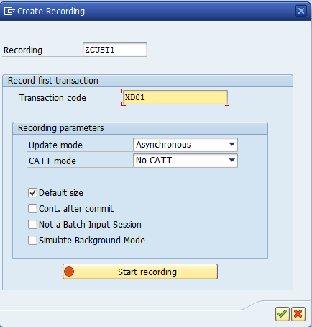

Step # 2. Select the recording and click on the program .

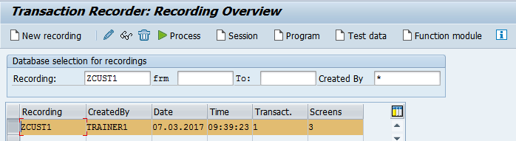

Step # 3. Select the Transfer from recording radiobutton and continue.

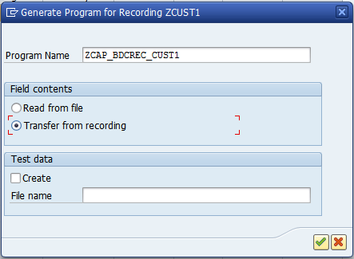

Step # 4. Program created automatically with the bdc performs.

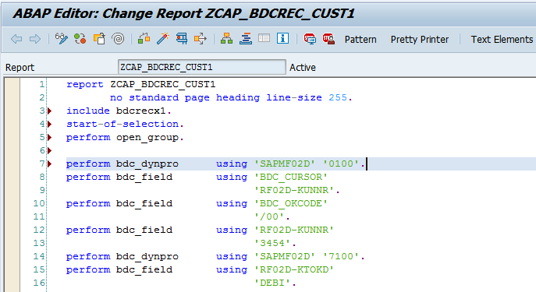

- BDC Session Method for Material Master.

Create a BDC Session method program for Materail Master T-Code MM01.

Program Logic Hints:

- Call BDC_OPEN_GROUP, BDC_INSERT and BDC_CLOSE_GROUP Functions.
- Create the flat file in the presentation system to attach the data.
- Process the foreground sessions with SM35 T-Code or Process with background job using the Predefined program RSBDCSUB in SE38.

Reference T-Codes and Tables:

T-Codes: SE38 and MM01/02/03 Tables: MARA, MARC and MAKT.

Step # 1. Go to SHDB and enter the MM01 t-code to record the material master data.

Step # 2. Create an executable program and write the session method logic .

Step # 3. Process the BDC Session Method through the SM35 T-Code.

- BDC Call Transaction Method for Vendor Master using the error handling.

Create a BDC calltransaction method program for the Vendor Master Transaction MK01 and handle the errors using BDCMSGCOLL.
Program Logic Hints:

- Create the flat file(Excel Format) in the presentation system to attach the data.

- Create an internal table IT_BDCMSGCOLL TYPE BDCMSGCOLL for the BDCMSGCOLL Structure.
- Call the FORMAT_MESSAGE Function Module and display the messages.
- Loop the IT_BDCMSGCOLL into WA_BDCMSGCOLL.

Reference T-Codes and Tables:

T-Codes: SE38 and MK01/02/03 Tables: LFA1 and LFB1.

Step # 1. Go to SHDB and enter the MK01 t-code to record the vendor master data.

Step # 2. Create an executable program and write the call transaction method logic.

Step # 3. Read the messages into IT_BDCMSGCOLL into WA_BDCMSGCOLL and display the messages for the user communication.

- Create a BDC Session Method with Table Control for Customer Master XD01 transaction.

Create a BDC Session method program with table control for Customer Master data to upload the customer master general data(Address Tab in XD01) and customer master bank data (Payment Transaction Tab in XD01).

Program Logic Hints:

- Declare the two internal tables, First one is for the general data and second one is for the bank data.

- Call two GUI_UPLOAD function modules in the program.

- Create 2 Flat Files or 2 Excel Files in the presentation system to attach the data.
- Customer General Data.
- Customer Bank Data.

- Loop the General Data BDC performs to the first Internal table and Bank Data BDC performs to the Second Internal table.

Reference T-Codes and Tables:

T-Codes: SE38 and XD01/02/03. Tables: KNA1 and KNB1.

Step # 1. Go to SHDB and enter the XD01 T-Code to record the customer master general data in Address Tab and Bank data in Payment Transaction Tab as shown in the below screens.

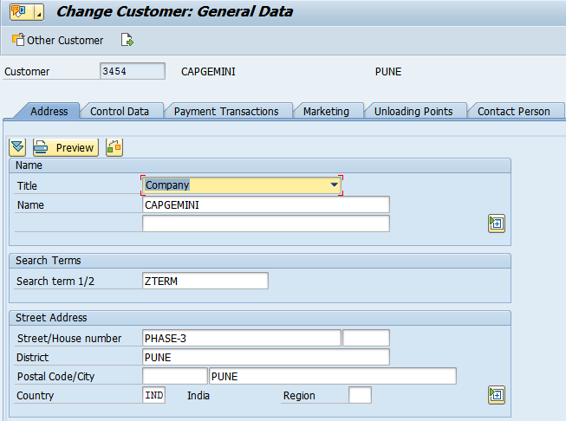

Step # 2. Click on the Payment Transactions tab to enter the multiple bank details .

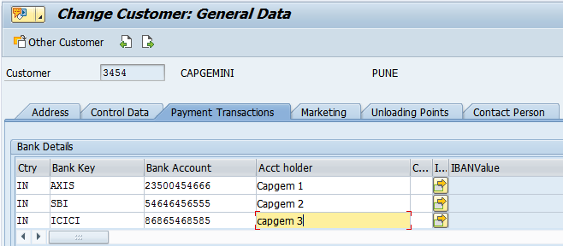

Step # 3. Prepare the BDC Session Method based on the recording and upload the customer master data with multiple bank details.

Step # 4. Check the customer data in XD03 transaction and check the uploaded entries in KAN1 and KNB1 Tables.

- LSMW- Legacy System Migration Workbench.

Data upload through the LSMW Batch Input Recording technique for the Materail Master MM01 transaction.

Reference T-Codes and Tables:

T-Codes: LSMW and MM01/02/03. Tables: MARA,MARC and MAKT.

Hint: Select the Batch Input Recording.

LSMW- Legacy System Migration Workbench.Data upload through the LSMW Direct Input Technique for the Materail Master MM01 transaction.

Reference T-Codes and Tables:

T-Codes: LSMW and MM01/02/03. Tables: MARA,MARC and MAKT.

Hint: Select the Standard Batch/Direct Input Method Radiobutton.

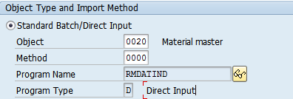

Lab 2-1 Enhancements and Modifications
Goals | - How to use Enhancements and Modifications
Time | 60 Minutes
Lab Setup | Connectivity to SAP server  Login details for connecting to SAP server

- ABAP Dictionary Table Enhancements Using the Append Structure.

ABAP Dictionary Table Enhancemetns for Vendor Master Table (LFA1) and add any Fields by using the Append structure.

Create the Fields, Data Elements and the Domains should start with the customer name space Starting with ZZ or YY as shown in the below screens.

Step # 1: Go to SE11 T-Code to Crate the Data Element.

Step # 2: Go to SE11 T-Code to Crate the Domain. Activate the Domain and Data element.

Step # 3: Provide the data element and domain inside the append structure and back to table you can find the fields under .Append structure.

- ABAP Dictionary Table Enhancements Using the CI (Customizing Includes).

ABAP Dictionary Table Enhancemetns for Purchase order Table (EKKO) :Add any ZZFields by using the CI_EKKODB Structure.

Create the Fields, Data Elements and the Domains should start with the customer name space starting with ZZ or YY as shown in the below screens.

Step # 1: Go to Table EKKO Purchase Order Header.

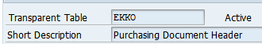

Step # 2: Double click on the CI_EKKODB Structure.

Step # 3: Add the fields in CI_EKKODB Structure as shown in the below screen.

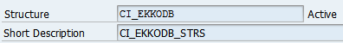

Eg:

ZZFAX1 Types ZZFAX1 CHAR 10 0 Fax
NAME Types NAME CHAR 35 0 Employee's last name
ZZFAX123 Types ZZFAX123 CHAR 10 0 FAX
ZZTELNO Types ZZTELNO CHAR 10 0 TELEPHONE NO
ZZTAN Types ZZTAN CHAR 8 0 DFHGTFRGH
ZZSOU Types ZZSOUACH_INCLUDE1 CHAR 5 0 ZZSOUACH_INCLUDE1

- Create a Classic BADI and Implement it.

Step # 1: Create the table type and line type by using the T-code SE11.

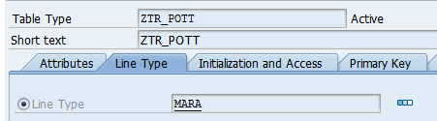

Step # 2: Create a classic badi by using the T-code SE18, go to utilities and select the Create Classic BADI option.

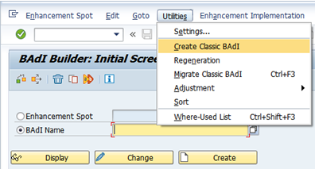

Step # 3: Provide the BADI defenetion name.
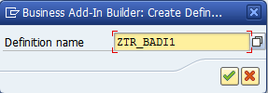

Step # 4: Provide the Interface name and Method name.
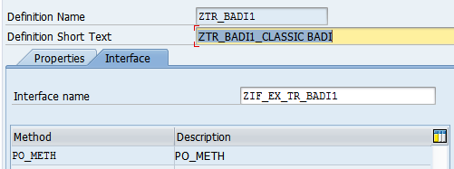

Step # 5: Provide the Method name and Parameters.

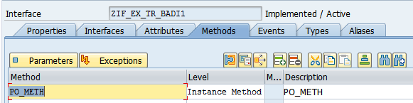

Step # 6: Changing parameter eg: C_MARA is requied for the Internal table declarations of Table type.

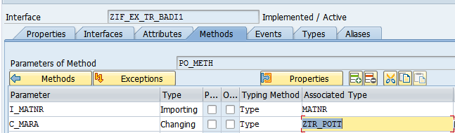

Step # 7: Implement the Classic BAdi by using the SE19 T-Code.

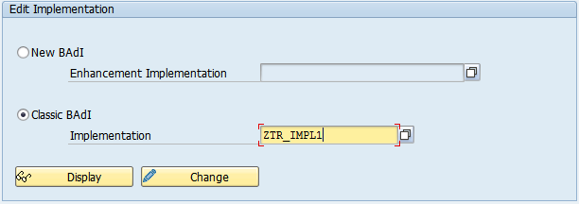

Step # 8: Create an executable program in SE38 and Call the Classic BADI By using the CALL METHOD CL_EXITHANDLER=>GET_INSTANCE

- Create a transaction variant for MM01 T-Code (Material Master).

Step # 1: Create the transaction variant by using the T-Code SHD0 and provide the transaction code MM01 and click on create button.

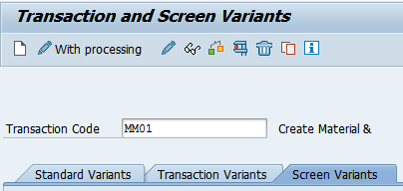

Step # 2: Provide the required material details and continue.

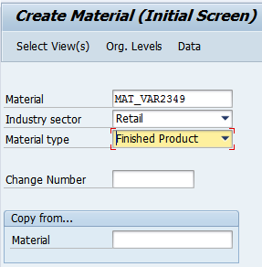

Step # 3: Provide the screen variant name, short description and click on continue.

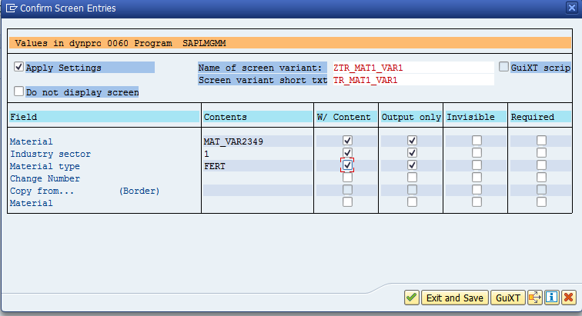

Step # 4: Provide the screen variant name, Short description and click on exit and save button.

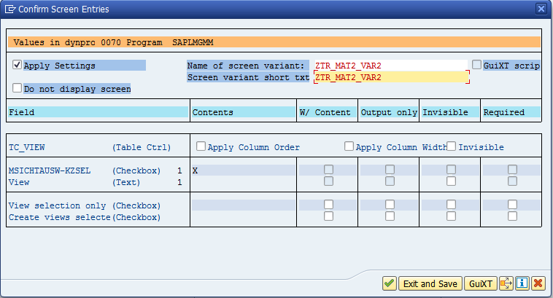

Step # 4: In the main screen navigate → Click on Goto menu and click on the create variant transaction.

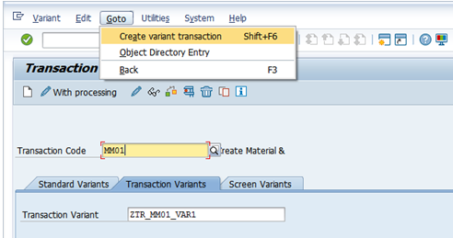

Step # 5: Provide the Short Text and continue.
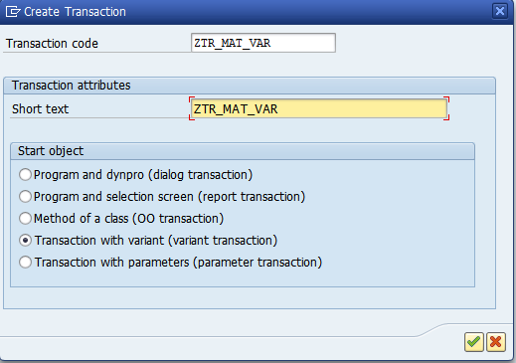

Step # 6: Select the GUI Support all options and continue.
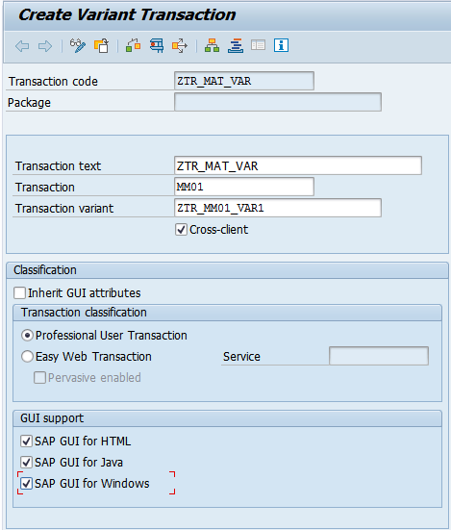

Step # 7: Execute the transaction variant .

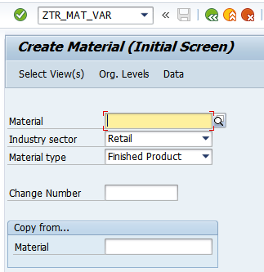

Lab 3-1 Smartforms

Goals | - How to design the Smartforms , Smart Styles and Text Modules
Time | 120 Minutes
Lab Setup | Connectivity to SAP server  Login details for connecting to SAP server

- Design the smartform to display the Flight booking details.

Step # 1. Go to smartforms t-code and design the smartforms with tables and templates based on the windows.

Step # 2. Go to smartstyles t-code and assign the same to the smartforms.

Step # 3. Go to smartforms t-code and create the textmodules and assign the same to the smartforms.

Step # 4. Go to SE38 t-code and write the main program logic for the smartforms and call the smartform from the driver program.

Smartform Code Logic:

Reference T-Codes and Tables:

Tables: SFLIGHT,SPFLI,SBOOK.

- Input of the Adobe form should be the Customer Number ,Flight date and Airline Code( From table SBOOKS).

- Title window : Hardcoded Text.

- Address window : Get the Flight details from table SFLIGHT for the Connection Number(CARRID) and Airline Code no(CARRID) and Flight date(FLDATE)

- Template window : Get the Flight schedule details from table SPFLI for the Connection Number(CARRID) and Airline Code no(CARRID) .

- Main window : Get the line item booking details from table SBOOKS and display the data in tabular format display the data for the table format in the MAIN WINDOW.

- Footer Window : Provide the system fields for the Date, Time and Page no.

Note: as shown below output of the smartform data may not be same in all the clients or servers.

Expected Output of the Smartform :

FLIGHT BOOKING DETAILS



Flight Details:  Airline Code: XXX  Connection XXX  Flight Date: XXX  Planetype: XXX  MaxCapacity: XXX  Frequency: XXX  Price:.XXX
  FLIGHT SCHEDULE DETAILS:
  AirlineCode | XXXX
  Name | XXX
  Departure City | XXX
  Destination Airport | XXX
  FlightTime | XXX
  Departure Time | XXX
  ArrivalTime | XXX

Customer  ID | Name of passenger | Customer  Type | Weight of Luggage | Weight unit | Flight class | Travel  Agency No

- Design the smartform to display the Customer-Flight Details

Step # 1. Go to smartforms t-code and design the smartforms with tables and templates based on the windows.

Step # 2. Go to smartstyles t-code and assign the same to the smartforms.

Step # 3. Go to smartforms t-code and create the textmodules and assign the same to the smartforms.

Step # 4. Go to SE38 t-code and write the main program logic for the smartforms and call the smartform from the driver program/Print Program.

Smartform Code Logic:

Reference T-Codes and Tables:

Tables: STRVELAG,SBUSPART,SCUSTOM

- Input of the smartform should be Customer No from table SCUSTOM

- Title window : Hardcoded text “CUSTOMER-FLIGHT DETAILS”.

- Address window : Get the BusPartner Details from table SBUSPART for customer no where SCUSTOM-ID = SBUSPART-BUSPARTNUM

- Template window : Get the Customer Flight details from table SCUSTOM for customer no

- Main window : Get the Customer booking line items details from table SBOOK for the customer number into the main window and display the data into the table format.

- Footer Window : Provide the system fields for the Date, Time and Page No.

Note: as shown below output of the smartform data may not be the same in all the clietns or the servers.

Expected Output of the Smartform :

CUSTOMER-FLIGHT DETAILS

BusPartner Details:  Flight Partner Number: XXX  Business partner ID :XXX  Contact person : XXX  Telephone number: XXX
  Customer Flight DETAILS:
  Customer No | XXXX
  Customer Name | XXX
  Street/City | XXX
  Country | XXX
  Telephone
  Email

Airline Code | Connection Number | Flight date | Booking number | Weight | Flight Class | Agency no | Booking price(Local currency)

Lab 4-1 Adobe Forms

Goals | - Understand and use the Adobe Interfaces and Forms.
Time | 120 Minutes
Lab Setup | Connectivity to SAP server  Login details for connecting to SAP server

- Design the Adobeform to display the Flight Booking details.

Step # 1. Go to SFP t-code and creaet the Adobe Form Interface.

Step # 2. Go to SFP t-code and design the Adobe Form with tables and other properties as shown in the below screen.

Step # 3. Go to SE38 t-code and write the main program logic for the Adobe form and call the Adobe form from the driver program/Print program.

Adobe Form Design Logic:

Reference T-Codes and Tables:
Tables: SFLIGHT,SPFLI,SBOOK.

- Input of the Adobe form should be the Customer Number ,Flight date and Airline Code( From table SBOOKS)

- Hardcoded text “MY FLIGHT DETAILS ” for Form Heading .

- Get the corresponding Airline Code from table SBOOKS.

- “Flight Details” and“Flight schedule” are Hardcoded text and data to be displayed based on the Airline Code and Connection

- Logic:
- Get the Flight details from table SFLIGHT for the Connection Number(CARRID) and Airline Code no(CARRID) and Flight date(FLDATE)
- Get the Flight schedule details from table SPFLI for the Connection Number(CARRID) and Airline Code no(CARRID) .

- Get the line item booking details from table SBOOKS and display the data in tabular format

- As the footer display the message ‘Refund will be made to you subject to applicable cancellation charges. No refunds will be made for cancellations inside 24 hours(Twenty-Four) prior to departure’

- Logo should be displayed only on the first page.(Use java script for this)

- Footer should be displayed only on the last page.(Use Java Script for this)

Note: As shown below output of the Adobe form data may not be the same in all the clietns or the servers.

FLIGHT BOOKING DETAILS

Customer No:XXXX
Flight date: XXXX

Flight Details:  Airline Code: XXX  Connection XXX  Flight Date: XXX  Planetype: XXX  MaximumCapacity: XXX  Frequency: XXX  Price:.XXX |  | Flight Schedule details:  AirlineCode: XXXX  Name: XXX  Departure City : XXX  Destination Airport: XXX  FlightTime: XXX  Departure Time:XXX  ArrivalTime: XXX

Customer  ID | Name of passenger | Customer  Type | Weight of Luggage | Weight unit | Flight class | Travel  Agency No

Terms and Conditions:
Refund will be made to you subject to applicable cancellation charges. No refunds will be made for cancellations inside 24 hours(Twenty-Four) prior to departure

Lab 5-1 ALE and IDOCS

Goals | - Configure the ALE IDOC Steps for Standard and Customised Applications.
Time | 120 Minutes
Lab Setup | Connectivity to SAP server  Login details for connecting to SAP server

- Configure the ALE and IDOC Customised steps for the segments, Idoc type, Messages and Assign Idoc type to Messge type for your own ‘Z’ or ‘Y’ Tables and Customised Applications.

Step # 1. Create the ‘Z’ or ‘Y’ tables in the outbound systmes.

Create the custom table for Eg: ZEMP_TAB by using the T-Code SE11.

Step # 2. Create the Segments.

Create the segments based on the step # 1 (‘Z’ or ‘Y’ table fields) by using the T-Code WE31.
Eg: ZEMP_SEG1.

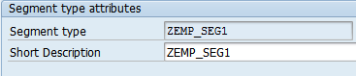

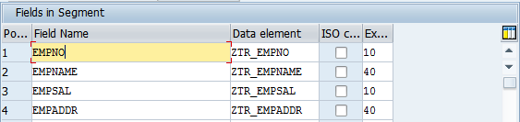

Step # 3. Create the Basic IDoc type.

Create the Basic Idoc type by using the T-Code WE30. Eg: ZEMP_IDOCTYPE01.

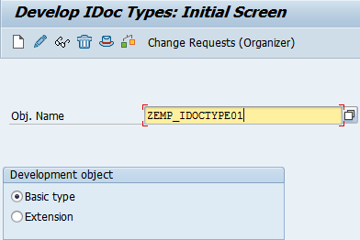

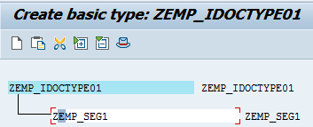

Step # 4. Creat the message type.

Create the custom message type by using the T-Code WE81. Eg: ZEMP_MASTER.

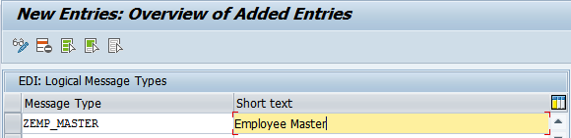

Step # 5. Assign the IDoc type to message type.
Assign the Idoc type to Message type by using the T-Code WE82. Eg: ZEMP_IDOCTYPE01 is assigned to ZEMP_MASTER.

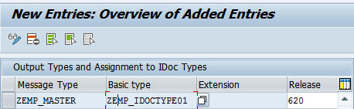

- Configure the standard ALE and IDOC steps for the Client to Client with in the same server by using
The Message type MATMAS for Material Mater (T-Code MM01).

Create the New Materials (T-code MM01) in the Outbound System Client Eg:100 and Release the Materials by using the Standard IDOC and the Materails should be posted automatically in the Inbound system Client Eg: 200.

Step # 1. Create the Logical Systmes.

Use predefined Logical Systmes which are already created. Ref the transaction code: SALE or BD54

Step # 2. Assign the Logical Systems to Client.

Ref predefined Logical Systmes which are already assigned to the clients. Ref the transaction code: SALE or SCC4

Step # 3. Create the new RFC Connection.

Create new R/3 RFC connection . Ref the transaction code: SALE or SCC4

Step # 4. Create the new PORT Connection.

Create the new port ref the transaction code: WE21

Step # 5. Create the new Partner Profiles at Outbound Systems.

Create the new partner profile ref the transaction code: WE20

Step # 6. Create the new Partner Profiles at Inbound Systems.

Create the new partner profile ref the transaction code: WE20

Step # 7. Distribute the Model View.

Distribute the Model view by using the BD64

Step # 8. Create the Material Master .

Create the new material master in outbound by using the MM01 T-code.

Step # 9. Release the Materials list by using the BD10 T-code.

Select the list of range materials to release from outbout to inbound.

Step # 10. Check the IDOC List by using the WE02/09 T-Code at Outbound .

Check the Idoc Status at outbound side.

Step # 11. Test the IDOC by Using the T-code WE19 at Outbound .

Check the Segments data is proper or not by using IDOC test tool .

Step # 12. Check the IDOC List by using the WE02/09 T-Code in Inbound.

Check the Idoc Status at inbound side.

Step # 13. Check the Material Mater status in MM03 or MARA and MAKT Tables in Inbound.

Check the Materials are posted or not in inbund MM03

Lab 6-1 Transports

Goals | - How to Release the Objects from the DEV to QAS to PRD and to Understand the Version Management.  DEV - Development System. QAS - Quality Assurance System.  PRD - Production System.
Time | 30 Minutes
Lab Setup | Connectivity to SAP server  Login details for connecting to SAP server

- Develop the ZObjects in DEV (Developmet) System and release the same to QAS(Quality) System by using the Trasportation.

Step # 1. Create a user defined package Eg: ZCAP_PACKAGE by using the T-Code SE21.

Step # 2. Create a user defined ZObject Eg ZSALES_ORD_REP1 (Executable Program) and assign the same object to the package Eg:ZCAP_PACKAGE.

Step # 3. Go to the program and Navigate →Utilities and select the Versions→ Version Management to know the object request.

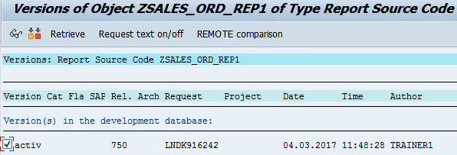

Step # 4. To see the modifiable objects, Select the Workbench Requests and Modifiable status check box by using the T-Code SE01/SE09/SE10.

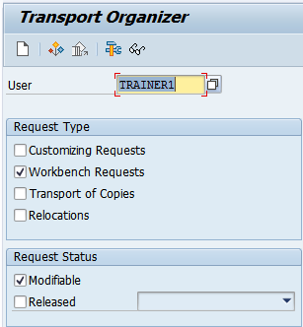

Step # 5. Release the object task Eg: LNDK916242 and request number LNDK916241 by using the
T-Code SE01/SE09/SE10.

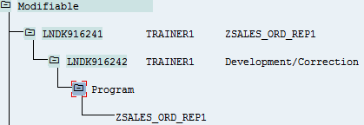

Step # 6. To see the Released objects, Select the Workbench Requests and Released status check box by using the T-Code SE01/SE09/SE10.

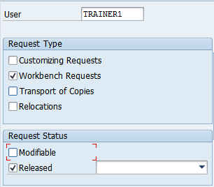

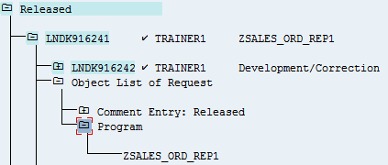

Step # 7. Modify the program code(V2) after release and create the new task and repeat the above steps.

Go to the program and Navigate →Utilities and select the Versions→ Version Management to compare the two versions of V1 and V2 Code.

